**How to create/configure linked roles between work item types? (or How to establish linked roles between work items )?**

1. Go to Work Items--> Enumerations
2. In the Enumerations page, look for [workitem-link-role-enum.xml](https://almdemo.polarion.com/polarion/svnwebclient/fileDownload.jsp?attachment=false&url=%2FSandbox%2FLakshmiLearn2%2F.polarion%2Ftracker%2Ffields%2Fworkitem-link-role-enum.xml) and click Edit Button

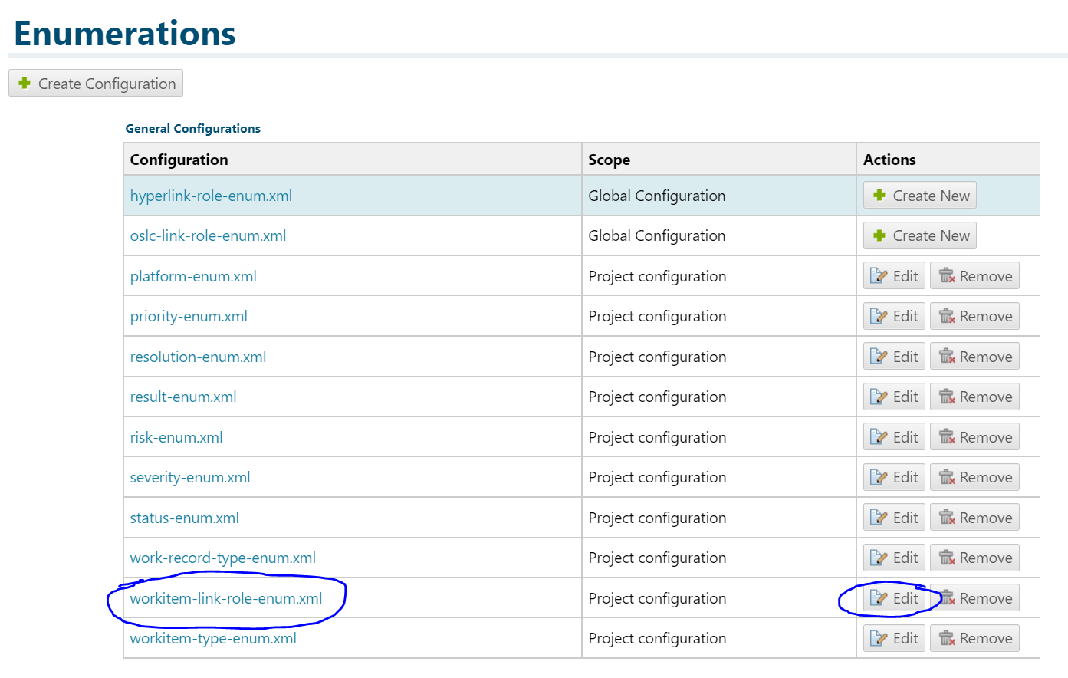

The workitem-link role-enum.xml page opens as below. It displays the list of all link roles available.

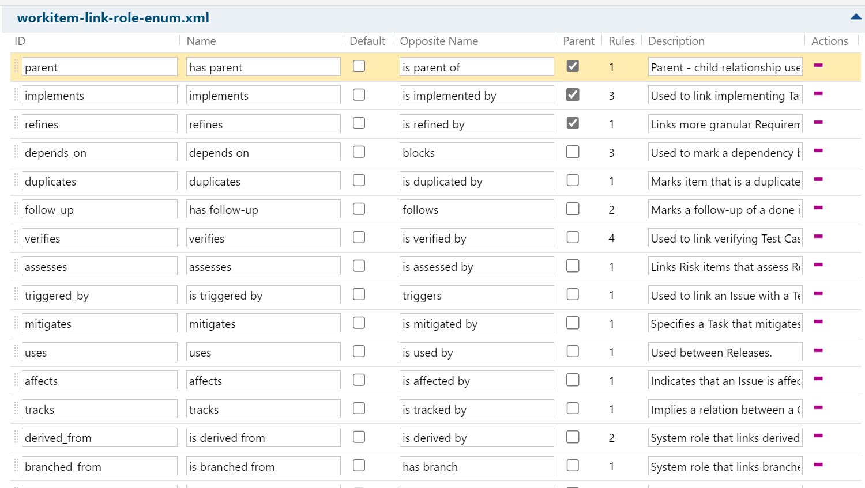

Select the link role which you want to establish/configure between work item types. The selected row would turn yellowish orange.

Then scroll down and go to "Rule for link role" section. Here , you select the "from types" and "to types". (This means the above selected link role will be established between the two work items types that you define in the "from types" and "to types" section.)

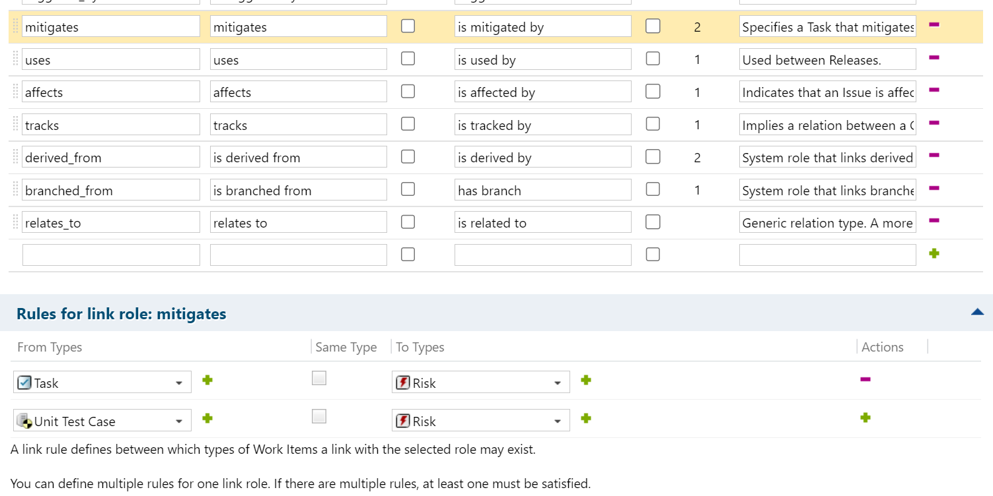

And finally Save it.